

Bike Ride Request Demand Forecasting Using Machine Learning

Archit Rawat
^{B.} Tech (CSE) 5th Sem, GEHU, Dehradun

(Department of Computer Science and Information Technology)

A thesis submitted in fulfilment of the requirements for the Mini Project of B. Tech in Computer Science

Abstract - The idea of this project is “Bike Ride Request Demand Forecasting” which provides dataset of Capital Bikeshare in Washington D.C. and asked to combine historical usage patterns in order to forecast bike rental demand. This dissertation will extend this work, working with a broader range of project not only just focusing on the phrase of model building but all phases of KDD (knowledge Discovery in Databases).
This dissertation focuses on Citi Bike which is one of the biggest bike share projects in the world, collects Citi Bike data and integrates the data to a model ready format. Two basic predictive models and One complex deep learning model are built and compared using multiple modelling algorithms, four different techniques are used to increase accuracy and modelling performance of the algorithms.
This paper learns many experience from case study of various Research Papers on topic “Bike Sharing Demand”, and seek to build optimize predictive model with smallest error rate. This project generally answers a question of “How many bikes will meet users’ demand in a future certain time”, the future work of this project will be to focus on combining weather and holiday database along with seasonal patterns and docking station’s activity. The realistic meaning of this dissertation is to provide an overview solution for bike rebalance problem and helps to better manage Ride rental programs.

Key words - Data Transformation, Model, Linear Regression, Random Forest, ConvLSTM, Result, Error.

CERTIFICATE

Certified that Mr. Archit Rawat (Roll No.- 2218456) has developed mini project on “Bike Ride Request Demand Forecasting” for the CSE V Semester Mini Project Lab in Graphic Era Hill University, Dehradun. The course study carried out by Students is their own work as best of my knowledge.

Date:15-01-2025

Mr. Amit Gupta
(CSE Department)
Project Guide

ACKNOWLEDGEMENT

I would like to express my special thanks to my Class Coordinator Ms. Manika Manwal and our Project guide Mr. Amit Gupta who gave me the golden opportunity to do this wonderful mini-project on the topic “Bike Ride Request Demand Forecasting”, which also helped me in doing a lot of research and I came to know about so many new things. I am really thankful to them.
Secondly, I would also like to thank my friends and my seniors who helped me a lot in finalizing this project within the limited time frame. I wish to thank my parents for their continuing support and encouragement. At last but not least, I am greatly indebted to all other people who directly or indirectly helped me during this work.

Archit Rawat
Roll no.-2218456
CSE-E2-V-Sem
Session: 2024-25
GEHU, Dehradun

TABLE OF CONTENTS

Introduction …………………………………………………………… 5
1.1 Background of the Project
1.2 Overview of the Dataset
Objectives ……………………………………………………………... 5
2.1 Predict Ride Demand
2.2 Identify High-Demand Areas
2.3 Showcase Spatial and Temporal Patterns
2.4 Understand Rideable and User Preferences
Technologies Used …………………………………………………………….. 6
3.1 Programming Languages and Libraries
3.2 Tools for Data Visualization
3.3 GUI Development Tools
Functionalities
4.1 Data Cleaning and Preprocessing ………………………………………….. 6
4.2 Feature Engineering and Data Transformation …………………………….. 7
4.3 Exploratory Data Analysis …………………………………………………. 8
4.4 Model Implementations ……………………………………………………. 10
Implementation Details
5.1 Model-Specific Transformations …………………………………………… 11
5.2 Modular Workflow for Saving and Loading Data ………………………… 11
5.3 Results Analysis ……………………………………………………………. 12
Future Improvements ……………………………………………………… 15
6.1 Seasonal Pattern Analysis
6.2 Incorporating Weather and External Factors
6.3 Development of a Mobile/Web Application
6.4 Real-Time Prediction and Optimization Framework

Conclusion …………………………………………………………….. 16
7.1 Summary of Findings
7.2 Key Takeaways and Limitations
Applications …………………………………………………………… 16
8.1 Real-World Uses for Citibike, OLA, and Similar Services
8.2 Demand Forecasting and Resource Allocation

Appendix ……………………………………………………………… 17
9.1 CitiBike Raw Dataset
References …………………………………………………………….. 17
10.1 Research Papers
- Introduction
1.1 Background of the Project:
Bike-sharing systems, such as Citibike, provide an eco-friendly and convenient transportation option for urban dwellers. However, to ensure the effective functioning of these systems, predicting demand accurately is crucial. Proper demand forecasting helps in managing fleet distribution, station balancing, and optimizing resources for better service delivery.
This project aims to build a demand forecasting system for bike-sharing services, specifically Citibike, using machine learning techniques to predict ride requests at different times of the day, identify high-demand areas, and understand user preferences. The ultimate goal is to assist companies in optimizing their operations, minimizing downtime, and ensuring that bikes are available where and when they are needed the most.

1.2 Overview of the Dataset:
The dataset used in this project is provided by Citibike, a popular bike-sharing service. It contains data about individual bike rides, including the time of ride start and end, the stations where bikes were picked up and dropped off, the bike type (electric or classic), and the user type (member or casual).
Key Features:
Ride IDs: Identifiers for each ride.
Rideable Type: Whether the bike used was a classic or electric bike.
Start and End Station: The stations where rides began and ended.
Geographic Coordinates: Latitude and longitude values for both the start and end locations.
User Type: Whether the user was a member or a casual user.
Timestamps: The start and end times of each ride, which allow us to extract temporal features like time of day, day of the week, and seasonality patterns.
Data processing steps include handling missing values, detecting and removing outliers, and transforming temporal and spatial features into suitable formats for model input.

- OBJECTIVES
2.1 Predict Ride Demand:
The primary goal of this project is to predict the number of bike ride requests at various times and locations. Accurate predictions will help optimize bike distribution across stations, reduce waiting times for users, and improve service quality. Forecasting ride demand allows for better planning of bike availability, both for peak and off-peak hours.
2.2 Identify High-Demand Areas:
Another key objective is identifying stations or regions that consistently experience high or low demand. This information is essential for reallocating bikes across stations, ensuring that busy locations have enough bikes, and that less crowded stations don’t become overcrowded with unused bikes.
2.3 Showcase Spatial and Temporal Patterns:
Understanding the spatial and temporal dynamics of ride requests is central to this project. Temporal patterns (such as peak hours or specific days of the week) and spatial patterns (such as popular stations or geographic areas with high demand) can reveal valuable insights for system optimization.
2.4 Understand Rideable and User Preferences:
By analyzing rideable type preferences (classic vs. electric) and user types (members vs. casual riders), the model will provide insights into how demand fluctuates based on bike type and user characteristics. For example, electric bikes may see higher usage during peak hours or in specific regions with more challenging terrain.
- TECHNOLOGIES USED

3.1 Programming Languages and Libraries:
The primary programming language used in this project is Python, which provides a robust ecosystem for data analysis and machine learning.
Key libraries used include:
Pandas: For data manipulation and preprocessing.
NumPy: For numerical operations.
Scikit-learn: For building machine learning models (e.g., Random Forest, Linear Regression).
TensorFlow/Keras: For building deep learning models such as ConvLSTM.
Matplotlib and Seaborn: For visualizing data and model performance.

3.2 Tools for Data Visualization:
Data visualization is a critical part of understanding the patterns within the dataset. The following tools were employed:
Matplotlib: For creating basic plots, including line plots, histograms, and box plots.
Seaborn: For generating more advanced visualizations like heatmaps, pair plots, and correlation matrices, which helped identify relationships between features.

3.3 GUI Development Tools:
For deploying the final model and enabling real-time predictions, a GUI interface will be developed using Tkinter. The GUI will allow users to input specific parameters and receive predictions for bike demand, as well as view historical trends.

- FUNCTIONALITIES

4.1 Data Cleaning and Preprocessing:
The data cleaning and preprocessing stage is crucial to ensure the quality and consistency of the dataset before applying machine learning models. We implemented several key steps to handle different types of data issues.

Handling Missing Data:
The dataset initially contained a small amount of missing data, especially in ride durations and geographical coordinates. Missing values were handled using the dropna() function, as this method removed rows with missing values and ensured the model received complete data.
Handling Duplicates:
We performed an initial check to remove any duplicate rows, ensuring that the dataset represented unique rides and their associated features. The duplicates were mostly caused by system glitches during data collection.
Outlier Detection and Removal:
We employed the Interquartile Range (IQR) method to detect and remove outliers from continuous variables like ride duration and distance traveled. Boxplots were used to visualize the distribution. Though outliers were not out rightly removed as after a detailed analysis it was found that the outliers were correct values that represented high and low demand areas.
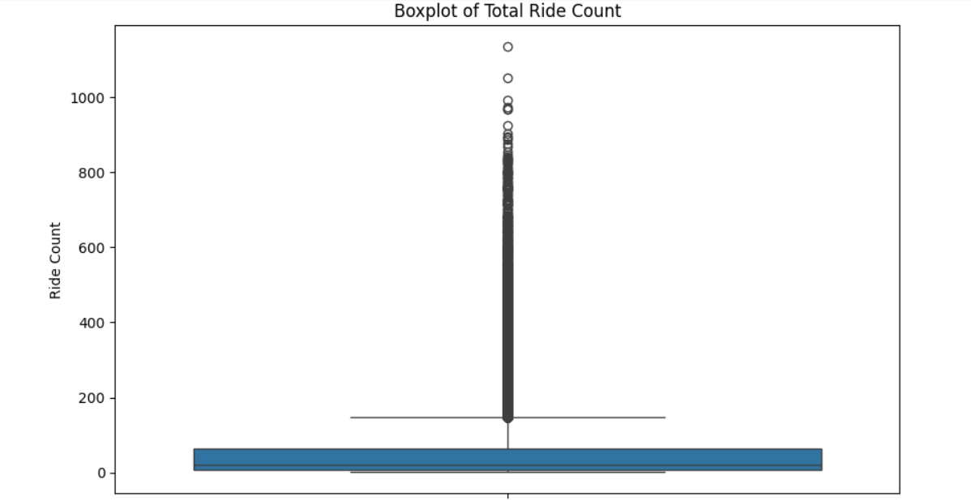

Data Transformation:
Date and Time Transformation: We split the timestamp features (started_at, ended_at) into separate columns representing hour, minute, and day of the week to capture temporal patterns. We also performed cyclical encoding on time-related variables like hours and days using sine and cosine transformations to handle the circular nature of time (e.g., 11 AM and 1 PM are close in time).
Geospatial Transformation: We transformed the station names and coordinates into more meaningful features by mapping stations to their respective latitude and longitude, making it easier for the model to recognize spatial patterns.

4.2 Feature Engineering and Data Transformation:
Feature engineering was critical for transforming the raw data into a format that could be fed into machine learning models. Several key transformations were applied to enhance the model's understanding of the relationships between features.

Categorical Variable Encoding:
Rideable Type and User Type Encoding: The categorical variables, such as rideable_type (electric or classic) and user_type (member or casual), were converted into binary values. This was done by applying a one-hot encoding method, which helped the model understand the relationship between user type and bike demand more effectively.
Aggregating Ride Count Data:
We created aggregated features to capture the total number of rides per station per time period (hour, day, week). This aggregation allowed us to evaluate bike demand trends over different timeframes and identify high-demand stations. For instance, the total ride count was calculated for each station during morning and evening peak hours.
Geospatial Feature Engineering:
Geographic Zones: We introduced a feature to categorize stations into different geographic zones (e.g., downtown, residential, business districts). This helped the model to identify whether demand patterns varied by region.

Temporal Feature Engineering:
Features such as hour_sin, hour_cos, weekday_sin, and weekday_cos were created to encode cyclical behavior in time. This was essential to model hourly fluctuations in bike demand, especially when considering rush hours and weekend patterns.
Ride Duration Calculation:
We created a new feature, ride_duration, by subtracting the started_at time from the ended_at time. This allowed us to model the effect of ride duration on demand, as longer rides could indicate areas where bikes were less likely to be returned on time.

4.3 Exploratory Data Analysis (EDA):
Exploratory Data Analysis played a pivotal role in understanding the underlying trends in the dataset. By visualizing different patterns and relationships, we gained valuable insights that informed our feature selection and modeling approach.

Time of Day Analysis:
We observed that bike demand was highest during morning (7 AM to 9 AM) and evening (4 PM to 6 PM) rush hours. We used histograms and line charts to demonstrate the clear peaks at these times. Additionally, demand during off-peak hours (midnight to 6 AM) was significantly lower.

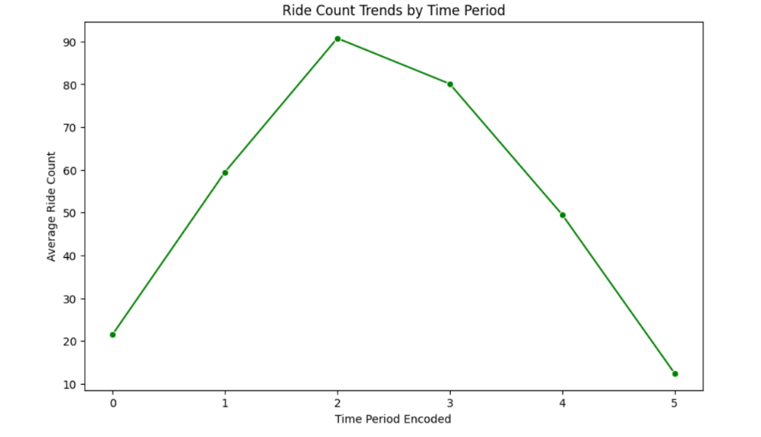

Day of Week Trends:
Weekdays saw higher usage than weekends, with Monday through Friday showing significantly more bike requests. This was particularly true for stations near business centers. A bar plot was used to compare ride counts across different days of the week, revealing weekday dominance.
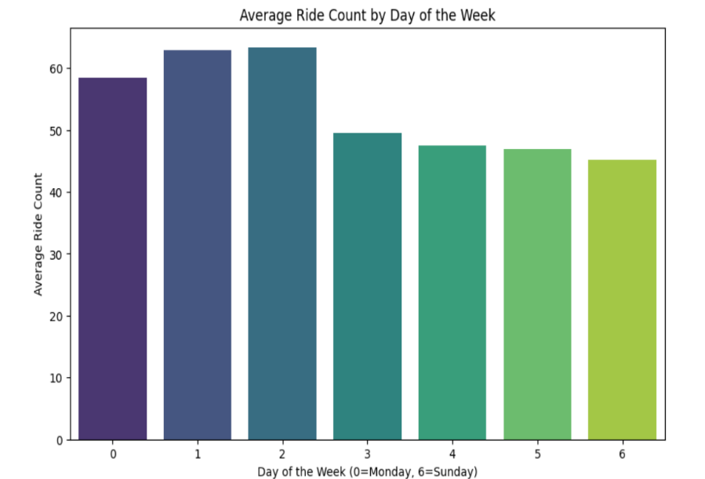

Geospatial Demand Analysis:
Heatmaps of ride counts across various station locations indicated that stations near transportation hubs (e.g., subway stations) had the highest ride requests. Stations in more residential areas had lower demand. We used scatter plots and heatmaps to visualize station clustering based on geographic demand.
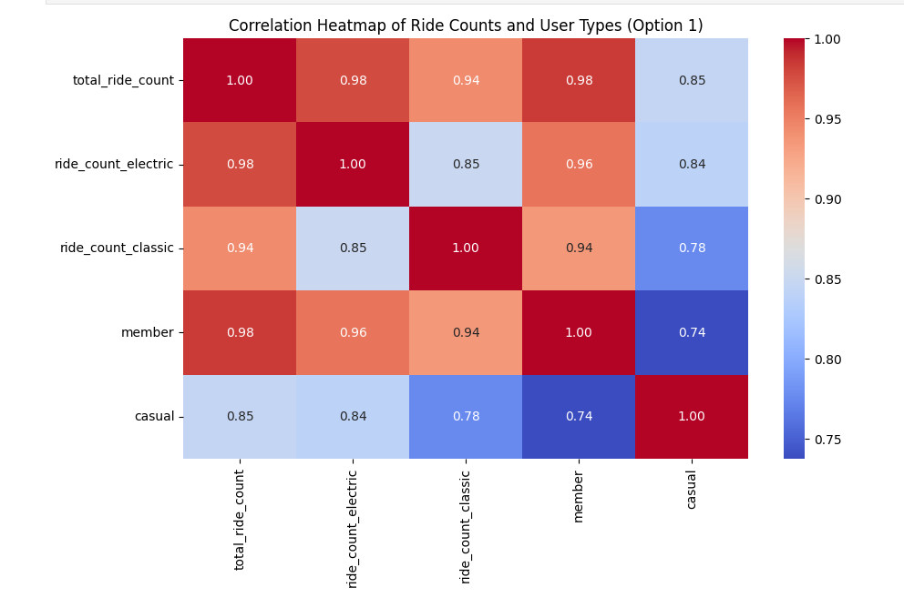
4.4 Model Implementations:
After preparing the dataset, several machine learning models were implemented to predict ride demand.
Linear Regression (LR):
As a baseline model, Linear Regression was used to predict ride demand based on the selected features. We performed feature scaling/normalization and Log transformation to optimize the model’s performance. Although it offered decent predictions, it struggled to capture non-linear dependencies and true feature importances.
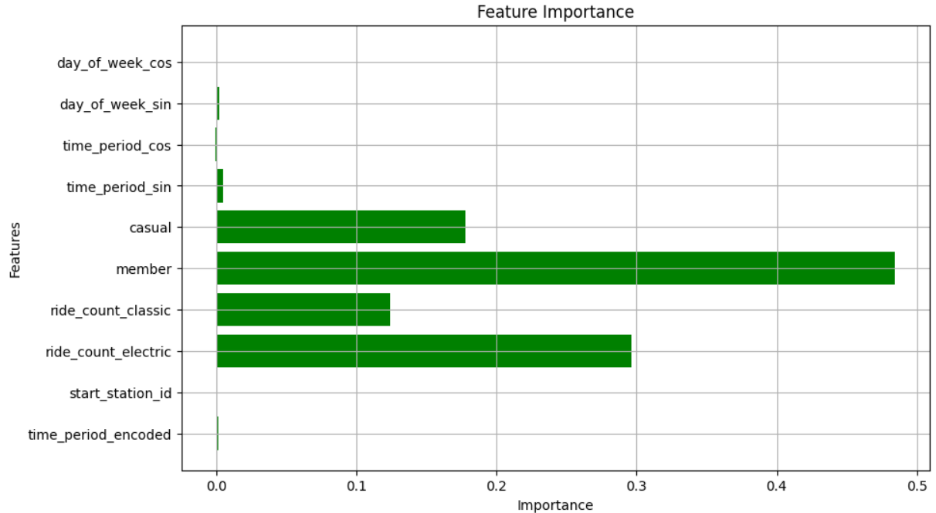

Random Forest (RF):
To improve on the linearity assumption, we implemented Random Forest. Random Forest is a more flexible model capable of capturing complex interactions between features. We performed hyperparameter tuning (e.g., adjusting the number of trees and tree depth) using cross-validation (5 - fold) to reduce overfitting. Random forest provided captured non-linear dependencies much better giving better feature importance.
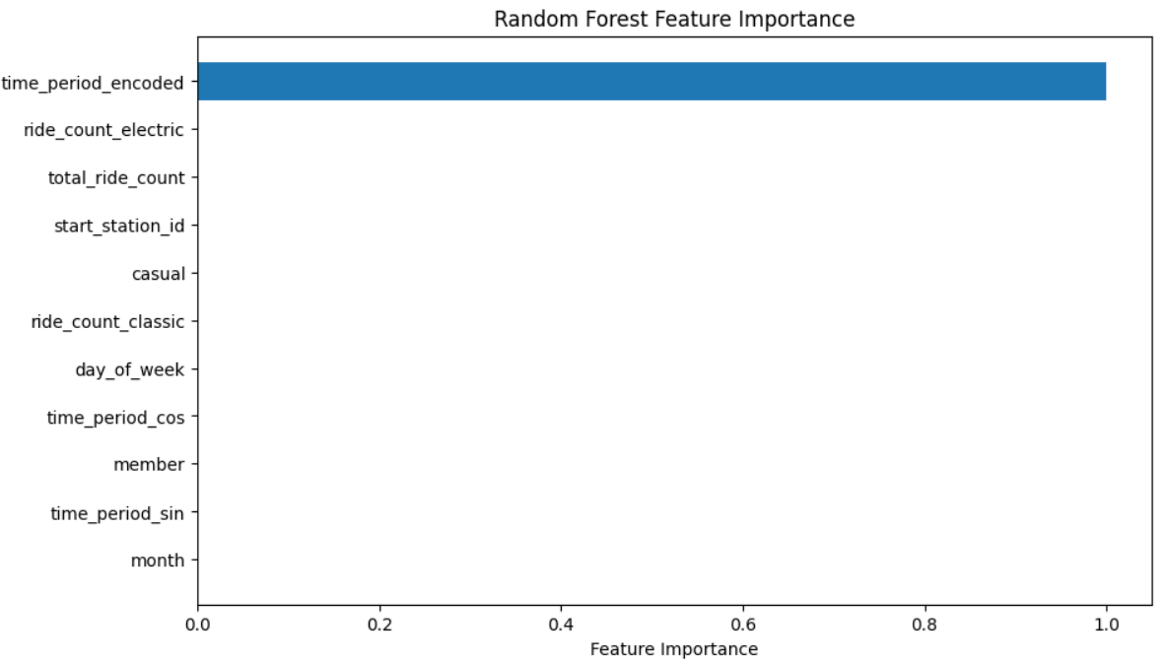
ConvLSTM (Planned Future Model):
We planned to use ConvLSTM for its ability to capture spatial-temporal dependencies. ConvLSTM models are particularly useful for time-series prediction with spatial data. We initially tested a basic ConvLSTM architecture with a few convolutional layers followed by LSTM layers. However, due to computational limitations and several modelling issues, we were only able to simulate the intended structure, with plans to optimize it later for more robust results.

- IMPLEMENTATION DETAILS

5.1 Model-Specific Transformations:
To prepare data for each model, we applied specific transformations based on the model's requirements.

Linear Regression:
For Linear Regression, we applied logarithmic transformations to ride counts to reduce skewness. Additionally, we scaled the data using Min-Max normalization, ensuring that all features had similar ranges, which improved convergence during model training.
Random Forest:
Random Forest benefited from a simple normalization process, as the algorithm is inherently robust to different scales of input features. We used Grid Search to find the optimal hyperparameters, including the number of trees, maximum depth, and minimum samples per leaf, which allowed for better generalization on unseen data.
ConvLSTM:
For ConvLSTM, the data needed to be reshaped into sequences of fixed length (e.g., 30 hours of historical data) to make use of temporal patterns. The data was divided into time windows of 30 hours, each representing demand patterns from the previous days. We ensured that both spatial and temporal features were properly aligned before feeding them into the model.

5.2 Modular Workflow for Saving and Loading:
To make the project more efficient and reusable, we implemented a modular workflow that saved and loaded key variables, processed data frames, and model results. This approach was instrumental in avoiding repetitive computations and ensuring that each stage of the project was independent of the others.

Saving Processed Data:
After cleaning and preprocessing, the processed data frames were saved in formats like CSV and pickle. This allowed us to load the preprocessed data directly in subsequent steps without rerunning the preprocessing code. For example, the feature-engineered data frame containing temporal and spatial attributes was stored as a pickle file, making it reusable for different models.
Variable and Model Saving:
During model training, key variables such as hyperparameter configurations, training logs, and results were saved. Additionally, trained model objects were serialized using libraries like joblib and pickle. This made it possible to reuse the trained models for evaluation or integration without retraining them.

Loading and Reusing Data:
In later stages, we seamlessly loaded saved data frames and variables. This ensured consistency across different experiments and facilitated comparisons between models. For example, while switching from Linear Regression to Random Forest, we loaded the same preprocessed data frame used in the previous model, maintaining a consistent input structure.
Result Saving for Analysis:
Predictions and evaluation metrics from each model were saved as separate files. This allowed us to analyze results without needing to rerun the models repeatedly. For instance, the predictions for Random Forest and their corresponding evaluation metrics (e.g., RMSE and R²) were stored, enabling us to focus on interpretation and analysis in later steps.

5.3 Results Analysis:
Model Performance:
Linear Regression: The model provided baseline results with moderate accuracy. It was effective in capturing overall trends but failed to detect complex, non-linear relationships.
It provided R² Score: 0.9927654287206705 and Root Mean Squared Error: 0.016852235871436715 for transformed values.
Though the point to be noted is that the accuracy depletes moderately for inverse transformed values and highly for non-transformed values. That’s why Linear Regression fails in terms of high performing model for the predictions.
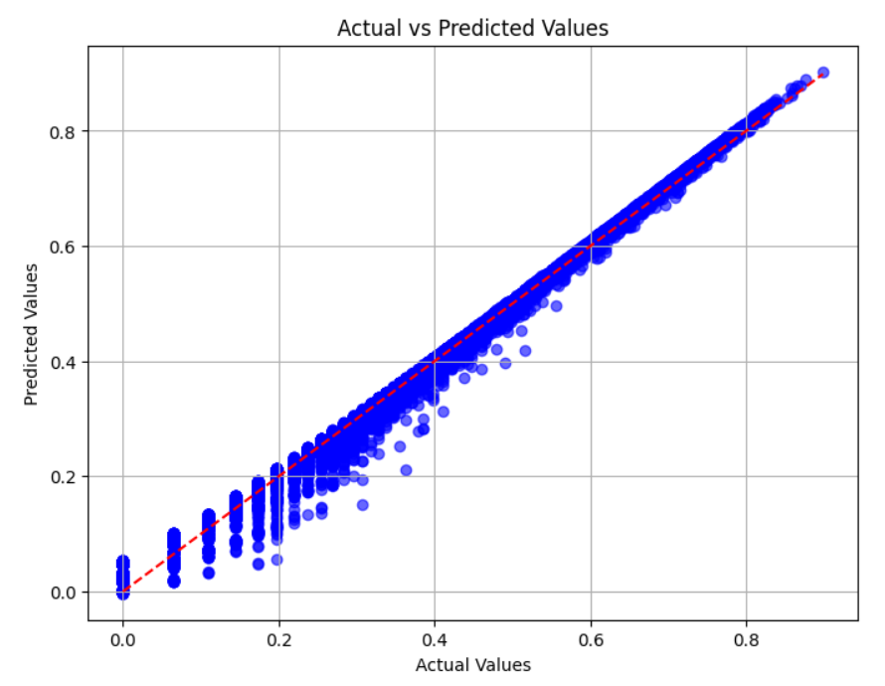

Random Forest: Significantly improved predictions, reducing errors (evaluated using RMSE and MAE metrics). It successfully captured interactions between features such as day of week, time of day, and station location.
With hyperparameter tuning using Cross-Validation Random Forest provided:
Fitting 5 folds for each of 81 candidates, totalling 405 fits
Best Hyperparameters: {'max_depth': 30, 'min_samples_leaf': 1, 'min_samples_split': 2, 'n_estimators': 200}
R² Score: 0.9999991757986647
Root Mean Squared Error: 0.00019217412687727898
Though Random Forest was faced with similar issue as Linear regression causing moderate accuracy in Inverse transformation and low accuracy in Non transformed values, It was still able to capture non-linear dependencies among features much better than linear regression.

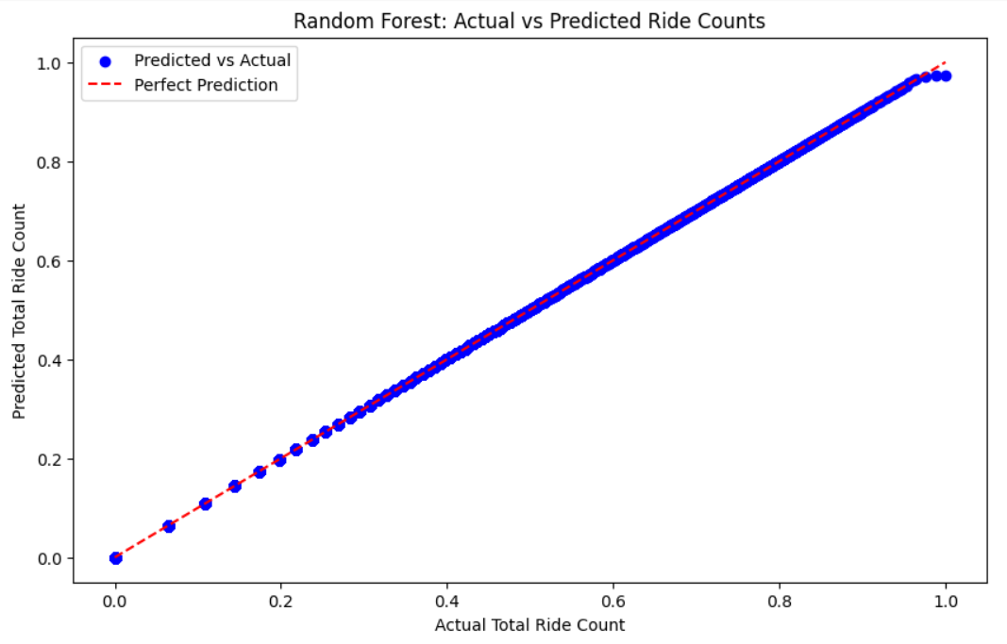

ConvLSTM: The ConvLSTM model was simulated and expected to outperform the other models once fully optimized. Although we couldn’t finalize training, initial results suggested its potential for capturing temporal and spatial dependencies more effectively than Random Forest and Linear Regression. ConvLSTM is a hybrid of Convolution network for capturing spatial dependencies and LSTM for capturing temporal dependencies. The model training showcased continuously decreasing training loss which is expected as the model learns from the training data and adjusts its parameters to better fit the training examples. But the validation loss shows a more fluctuating behavior suggesting that the model might be overfitting to the training data at some point.
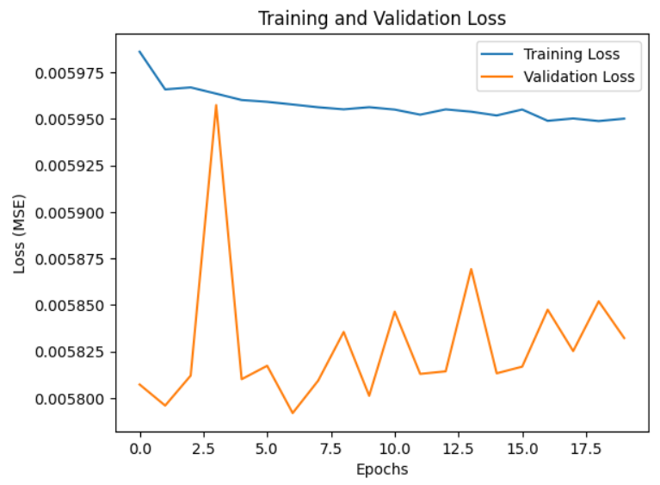
This means it is learning the training data too well, but not generalizing well to unseen data.
The overfitting issue might be due to the model being too complex or training too long without regularization or early stopping.
To counter these issues we can implement some solutions like:
Regularization: We can later add techniques like dropout or L2 regularization if necessary.
Early Stopping: We can implement early stopping based on the validation loss to prevent overfitting.
Model Tuning: Adjust the architecture, like reducing the number of layers or units, to reduce overfitting

- FUTURE IMPROVEMENTS

6.1 Seasonal Pattern Analysis:
One of the key limitations of our current approach is that it only accounts for data from a single season. Given that bike demand can vary significantly across different seasons, we believe incorporating data from multiple months will allow the model to account for seasonal fluctuations. For example, summer months tend to have higher demand due to warmer weather, while winter months may see a drop in demand due to colder temperatures. Expanding the dataset to cover different seasons will improve the model's ability to predict demand more accurately throughout the year and also help models to perform much better with larger data sets.
6.2 Weather and External Factors:
Another potential area for improvement is incorporating weather data into the model. Factors such as temperature, precipitation, and wind speed can have a direct impact on bike demand. For example, rainy weather or extreme temperatures could deter people from using bikes, especially for casual riders. By adding weather data to the features, we can further enhance the accuracy of the predictions, taking into account these external factors that directly influence demand. This will also help companies manage their resources much more efficiently.
Further incorporating holiday data into the project is essential for improving the accuracy and reliability of bike ride demand forecasting. Holidays often exhibit unique demand patterns, such as increased recreational usage or reduced commuting trips, which can significantly impact overall ride counts. By tagging holidays in the dataset, the model gains a better understanding of seasonal and event-specific trends, allowing it to generalize more effectively during similar periods in the future. This additional context helps reduce forecasting errors by accounting for anomalies in bike usage that typically occur on holidays. Furthermore, integrating holiday data enables bike-sharing companies to optimize resource allocation, such as repositioning bikes to high-demand areas during public holidays or long weekends.

6.3 Mobile/Web Application:
Looking ahead, we plan to develop a real-time prediction system for bike-sharing services that can be accessed through a mobile or web application. This system would allow users to check bike availability at nearby stations in real-time, providing them with accurate forecasts of bike demand. This type of application would not only improve the user experience by reducing wait times but also allow bike-sharing companies to optimize resource allocation, ensuring that bikes are available in high-demand areas when they are needed most. Further it can help companies even in real-time bike and station mappings.

6.4 Real-Time Prediction and Optimization Framework:
Integrating a real-time prediction framework would allow the model to process live data from Citibike stations and make dynamic predictions about bike demand for the coming hours. Additionally, a resource optimization system could be built to recommend bike redistribution strategies based on predicted demand.

.

- CONCLUSION

7.1 Summary of Findings:
Through the implementation of Linear Regression, Random Forest, and the initial setup for ConvLSTM, we have successfully modeled bike demand based on temporal and spatial features. We discovered that time of day and station location are crucial factors influencing bike usage. The Random Forest model, in particular, showed promising results in capturing the complex patterns in bike demand, providing a more accurate and reliable prediction compared to Linear Regression while maintaining linear and non linear relationships between features.

7.2 Key Takeaways and Limitations:
The key takeaway from this project is that advanced models like Random Forest (and potentially ConvLSTM) are much better suited for capturing the non-linear and spatial-temporal relationships in bike demand than traditional models like Linear Regression. However, there are still several areas for improvement, including accounting for seasonal variations and integrating weather data.

- APPLICATIONS

8.1 Real-World Uses for Citibike, OLA, and Similar Services:
The findings from this project can be directly applied to real-world bike-sharing services like Citibike and OLA. Accurate demand forecasting can help optimize bike placement, ensuring that high-demand stations have enough bikes available during peak times while preventing overcrowding at less popular stations. Moreover, this model can be used to forecast bike demand in real-time, helping companies optimize resource allocation on a daily basis. Main advantage of the model includes it’s general structure of ride forecasting instead of just focusing or implementing on bikes the model can be used for any type of ride forecasting and even extend to real-time ride mapping and locating.

8.2 Demand Forecasting and Resource Allocation:
This research can also be applied to other industries or services that rely on demand forecasting and resource allocation. By understanding how demand varies over time and space, businesses can make better decisions about inventory management, staffing, and logistics, ultimately leading to more efficient and cost-effective operations.

- Appendix
- Citibike Raw Datasets

X. References

- Sabiheh Faghih, Arpita Shah, Zehan Wang, Abolfazl Safikhani and Camille Kamga, “Taxi and Mobility: Modeling Taxi Demand Using ARMA and Linear Regression” - The 11th International Conference on Emerging Ubiquitous Systems and Pervasive Networks.

- Meerah Karunanithi, Parin Chatasawapreeda and Talha Ali Khan , “A predictive analytics approach for forecasting bike rental demand” - Decision Analytics Journal 11.

- Jiahui Feng, Hefu Liu, Jingmei Zhou and Yang Zhou, “A Spatial-Temporal Aggregated Graph Neural Network for Docked Bike-sharing Demand Forecasting”.

- Lingye Tan, Ziyang Zhang, and Weiwei Jiang, “Ride-Hailing Service Prediction Based on Deep Learning” - International Journal of Machine Learning and Computing, Vol. 12, No. 1.

- Xinyu Li, Yang Xua, Xiaohu Zhang, Wenzhong Shia, Yang Yue, Qingquan Li, “Improving short-term bike sharing demand forecast through an irregular convolutional neural network” - Preprint submitted to Elsevie.

- Zilu Kang, Yuting Zuo, Zhibin Huang, Feng Zhou, Penghui Chen, “Research on the Forecast of Shared Bicycle Rental Demand Based on Spark Machine Learning Framework” - 2017 16th International Symposium on Distributed Computing and Applications to Business, Engineering and Science.

- Wen Wang, “Forecasting Bike Rental Demand Using New York Citi Bike Data”.

Authors

Author – Archit Rawat,
B. Tech CSE 5th Sem,
Graphic Era Hill University, Dehradun,
01archit03@gmail.com..

